UNSTRUCTURED Field Experience Log & Reflection
Instructional Technology Department – Updated Summer 2015

Candidate:  Sheri Bashlor | Mentor/Title:  Mrs. Kimberley Spivey  Media Specialist | School/District:  Wayne County High School
Course:  ITEC 7460 |  | Professor/Semester:  Dr. Sherry Grove

(This log contains space for up to 5 different field experiences for your 5 hours. It might be that you complete one field
experience totaling 5 hours! If you have fewer field experiences, just delete the extra pages. Thank you!)

Date(s) | Field Experiences Activities/Times | PSC Standard(s) | ISTE Standard(s)
October 11, 2016 – 10:00 a.m. – 11:30 a.m.  October 18, 2016 – 10:00-11:30 a.m.  October 25, 2016 – 10:00 – 11:30 a.m.  November 1, 2016 – 10:00 – 11:30 a.m.  November 8, 2016 – 9:00 – 10:30 a.m. | Today my partner and I focused on getting to know one another as well as outlined a strategic plan for the next several weeks. I started by observing Mrs. Lindsay during one of her class periods. While I observed her, I looked for the “Big Four,” as described by Knight in Instructional Coaching (2007, pg. 23). Today she was teaching a lesson on dictionary skills. I noticed she is strong in the area of behavior management; her students were attentive, and she expressed clear expectations throughout the entire lesson. She understood the content in which she was teaching as well as had a strong understanding of where her students were academically. A formative assessment was given at the end of the lesson, which helped her to see if her students understood the new content she had introduced during the lesson. I did notice a need to involve more technology in her direct instruction. After the lesson, we met during her planning period to discuss my observation.  Today I modeled my first lesson with Mrs. Lindsay’s class. I first gave Mrs. Lindsay the observation sheet I will be using with her, in order for her to specifically see what I would be looking for in future lessons. Because Mrs. Lindsay and I had previously discussed that I would be using technology during a lesson on dictionary skills, I took time to gain a deep understanding of the lesson I was teaching as well as the audience to which I was going to be teaching. As mentioned in Instructional Coaching, it’s important for coaches to have that deep understanding of the content that he or she is going to be teaching (Knight, 2007, pg. 114). I learned Mrs. Lindsay’s behavior management system last session as well, in order to implement it during the lesson in which I taught today.  During third block planning after lunch, we discussed what we would be doing for the following week’s lesson. She first wanted to practice using the website www.dictionary.com with her students. She felt this would help encourage her to use the same strategies as she learns them. To me, this was a very simple place to start and made her feel very comfortable in doing so because the technology was easy to use during the lesson, and the students had previous experience with the tool.  I observed Mrs. Lindsay during a lesson and debriefed during our lunch and planning time.  Like before, I shared an observation form with Mrs. Lindsay as well as a copy of my lesson plans. I think both of these tools are important to share, as it reminds Mrs. Lindsay of what I’ll be looking for during the lessons I observe as well as help her see blueprints of the lesson at hand. This strategy, as recommended in Knight’s literature, is important during the coaching process (pg. 116). I used the same lesson plan format as before, the E.A.T.S. strategy. I went over the essential question and learning target with the students and explained to them they would be using a new technology tool in class today. After reviewing what students had learned about using the website, www.dictionary.com, to define a word as well as how to copy and paste their information, I had students to interactively show Mrs. Lindsay and me how to do both. Once all students modeled their accurate use of the tool and how to copy and paste, I showed them how to activate the Read & Write tool on their Chromebooks. We talked about the toolbar that appeared once students click on the tool and went over a copy of the commands that the tool could help students do. Today we focused on the Read Aloud feature. Students were amazed that the computer could read to them. They learned how to slow down and speed up the pace of the computer reader according to their need as well as highlight words during the process.  As I was modeling the lesson, I showed students a poster I created for them to refer to in order to remember for what the different buttons are used. The poster had buttons and their functions listed. I left Mrs. Lindsay the buttons that we hadn’t used yet for her to use in future lessons. For higher-level questioning, I asked students ways to use the tool throughout other disciplines as well as ways they could use the extension at home or in other places. According to Knight in Instructional Coaching, it’s important to include higher-level questioning techniques in all lessons (2007, pg. 165).  After the lesson, we met during lunch; Mrs. Lindsay seemed more excited today than I have seen her so far during the entire coaching process. She said she witnessed her students using a tool that could make them more independent not only in the classroom, but also in the real world. I was excited to see her enthusiasm increase after viewing the lesson. During our third-block planning, we discussed that I would observe her during the next lesson incorporate all of the technology tools we have used so far. We collaboratively planned the lesson together and agreed I would only observe during the next lesson, unless she needed my assistance in any way. We discussed ways to include all of the behaviors listed on the checklist throughout the lesson as well, which I think made Mrs. Lindsay feel more comfortable about being on her own during the entire lesson.  Today Mrs. Lindsay taught a lesson using technology, and I observed. As mentioned in Knight’s book, Instructional Coaching, a powerful way to learn how to model is through the “I Do It, We Do It, You Do It” approach (2007, pg. 163). My journal entries have conveyed that to be used throughout my teaching, and today Mrs. Lindsay experienced the “You Do It” part of the process.  Prior to the lesson, Mrs. Lindsay handed me her lesson plans. During the lesson, I tallied the behaviors seen throughout the lesson as she was teaching. She earned more tallies today than before, and I feel as though our collaborative planning approach contributed to that. I also feel Mrs. Lindsay was more confident than ever today, partly due to the collaborative planning as well. Collaborative planning is also illustrated as an important piece of coaching (Knight, 2007). I could also tell Mrs. Lindsay felt very familiar and comfortable using the technology tool. I think her buoyancy with the tool today could also be an effect from her familiarizing herself on a deeper level with the technology tool used with her students.  After the lesson, we ate lunch together and talked about her successful lesson. She responded to the positive comments and was excited to see the evolution in her teaching. We went over some formative assessments that her students completed during the lesson as well as discussed the next step in planning for next week. During our third-block planning, I showed her some tools for finding technology. I introduced her to Twitter and Feedly, both of which she had never used. I showed her how to use these tools to find more ways to embed technology in future lessons. We decided to have one more coaching session together next Tuesday. She’s going to find a new tool using either Twitter or Feedly, create a lesson plan, and teach next week. I’m going to observe her completing this lesson and lesson plan completely independent. She stated she felt great about the lesson she taught today but wanted to make sure she could do it completely on her own. I listened to her request and honored it; she was excited to have more tools in her tool belt for teaching. | PSC 1.2, 1.4, 2.3, 2.6, 2.7, 3.1, 3.2, 3.3, 3.6, 3.7, 5.2, and 6.3 | 1a., 1d., 2a., 2b., 2e., 2f., 2g., 2h., 3a., 3b., 3c., 3f., 3g., and 4b.
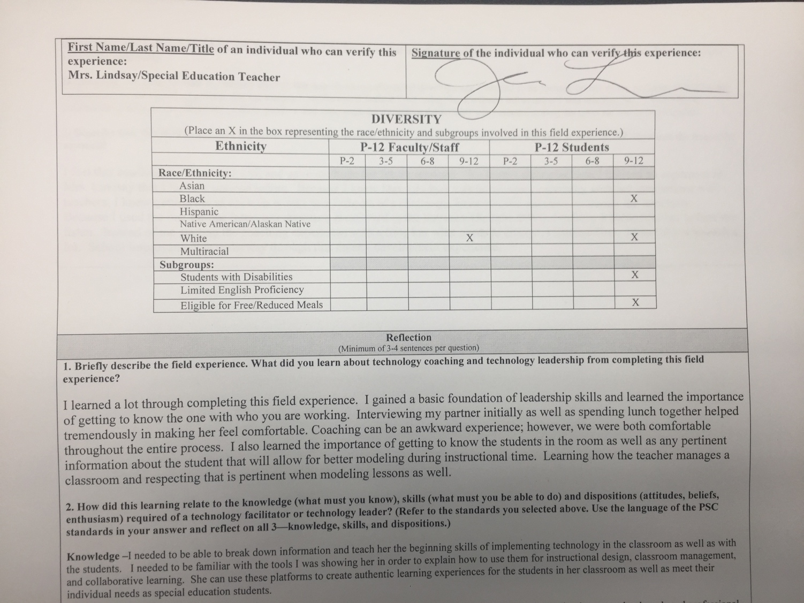

First Name/Last Name/Title of an individual who can verify this experience:  Mrs. Lindsay/Special Education Teacher | Signature of the individual who can verify this experience:  See above attached.

DIVERSITY
(Place an X in the box representing the race/ethnicity and subgroups involved in this field experience.)
Ethnicity | P-12 Faculty/Staff |  |  |  | P-12 Students
 | P-2 | 3-5 | 6-8 | 9-12 | P-2 | 3-5 | 6-8 | 9-12
Race/Ethnicity:
Asian
Black |  |  |  |  |  |  |  | X
Hispanic
Native American/Alaskan Native
White |  |  |  | X |  |  |  | X
Multiracial
Subgroups:
Students with Disabilities |  |  |  |  |  |  |  | X
Limited English Proficiency
Eligible for Free/Reduced Meals |  |  |  |  |  |  |  | X

Reflection
(Minimum of 3-4 sentences per question)
1. Briefly describe the field experience. What did you learn about technology coaching and technology leadership from completing this field experience?

I learned a lot through completing this field experience. I gained a basic foundation of leadership skills and learned the importance of getting to know the one with who you are working. Interviewing my partner initially as well as spending lunch together helped tremendously in making her feel comfortable. Coaching can be an awkward experience; however, we were both comfortable throughout the entire process. I also learned the importance of getting to know the students in the room as well as any pertinent information about the student that will allow for better modeling during instructional time. Learning how the teacher manages a classroom and respecting that is pertinent when modeling lessons as well.

2. How did this learning relate to the knowledge (what must you know), skills (what must you be able to do) and dispositions (attitudes, beliefs, enthusiasm) required of a technology facilitator or technology leader? (Refer to the standards you selected above. Use the language of the PSC standards in your answer and reflect on all 3—knowledge, skills, and dispositions.)
Knowledge –I needed to be able to break down information and teach her the beginning skills of implementing technology in the classroom as well as with the students. I needed to be familiar with the tools I was showing her in order to explain how to use them for instructional design, classroom management, and collaborative learning. She can use these platforms to create authentic learning experiences for the students in her classroom as well as meet their individual needs as special education students.
Skills – I needed to be able to communicate clearly to both the teacher and students in the classroom. I needed to implement technology-based professional learning that would allow her to share with her students and for her to see that in action prior to her implementation. I also needed to model my ideas and knowledge effectively.

Dispositions – In order to teach my partner through this one-on-one professional development, I needed to be focused on her as my audience as well as her students during the modeling process and see exactly how she could benefit from using the newfound information I was teaching her. The ability to collaborate, communicate effectively, and be positive and encouraging throughout the process was essential during the tasks we completed together.

3. Describe how this field experience impacted school improvement, faculty development or student learning at your school. How can the impact be assessed?

I feel this coaching session went well and gave me hope for future sessions. We have a clear plan, and I noticed an eagerness in Mrs. Lindsay that I had not noticed before. Because I knew Mrs. Lindsay was introverted, especially with her interactions with teachers, I knew getting her to open up would be a little bit of a challenge; however, she did open up during the interview. Because I used the one-on-one interview approach mentioned in the literature (Knight, 2007), I believe it helped for her to hear me listen. Instead of me starting the coaching experience with telling her what needs to change, I listened first. I liked this approach a lot. School improvement is underway through this faculty development experience.

