UNSTRUCTURED Field Experience Log & Reflection
Instructional Technology Department – Updated Summer 2015

Candidate: Sheri Bashlor | Mentor/Title: Kim Spivey, Media Specialist | School/District: Midway Elementary School, Pierce County
Course: ITEC 7400 |  | Professor/Semester:  Dr. Jo Williamson

(This log contains space for up to 5 different field experiences for your 5 hours. It might be that you complete one field
experience totaling 5 hours! If you have fewer field experiences, just delete the extra pages. Thank you!)

Date(s) | 1st Field Experience Activity/Time | PSC Standard(s) | ISTE Standard(s)
June 8th, 2015 | Pierce County Technology Camp, 8:00 a.m. – 1:00 p.m.  I helped plan and coach teachers for various classes offered during this summer’s technology camp. The focus courses included robotics, digital video production, Web 2.0, and game design. The electives students were exposed to were digital photography and non-animated graphic design. | 1. Visionary Leadership  Candidates demonstrate the knowledge, skills, and dispositions to inspire and lead the development and implementation of a shared vision for the effective use of technology to promote excellence and support transformational change throughout the organization.  2. Teaching, Learning, & Assessment  Candidates demonstrate the knowledge, skills, and dispositions to effectively integrate technology into their own teaching practice and to collaboratively plan with and assist other educators in utilizing technology to improve teaching, learning, and assessment.  3. Digital Learning Environments  Candidates demonstrate the knowledge, skills, and dispositions to create, support, and manage effective digital learning environments.  4. Digital Citizenship & Responsibility  Candidates demonstrate the knowledge, skills, and dispositions to model and promote digital citizenship and responsibility.  5. Professional Learning & Program Evaluation  Candidates demonstrate the knowledge, skills, and dispositions to conduct needs assessments, develop technology-based professional learning programs, and design and implement regular and rigorous program evaluations to assess effectiveness and impact on student learning.  6. Candidate Professional Growth & Development  Candidates demonstrate the knowledge, skills, and dispositions to engage in continuous learning, reflect on professional practice, and engage in appropriate field experiences. | ISTE Teacher Standard (s)  1. Teachers use their knowledge of subject matter, teaching and learning, and technology to facilitate experiences that advance student learning, creativity, and innovation in both face-to-face and virtual environments.  2. Teachers design, develop, and evaluate authentic learning experiences and assessments incorporating contemporary tools and resources to maximize content learning in context and to develop the knowledge, skills, and attitudes identified in the standards.  3. Teachers exhibit knowledge, skills, and work processes representative of an innovative professional in a global and digital society.  4. Teachers understand local and global societal issues and responsibilities in an evolving digital culture and exhibit legal and ethical behavior in their professional practices.  5. Teachers continuously improve their professional practice, model lifelong learning, and exhibit leadership in their school and professional community by promoting and demonstrating the effective use of digital tools and resources.  ISTE Student Standard (s)  1. Students demonstrate creative thinking, construct knowledge, and develop innovative products and processes using technology.  2. Students use digital media and environments to communicate and work collaboratively, including at a distance, to support individual learning and contribute to the learning of others.  3. Students apply digital tools to gather, evaluate, and use information.  4. Students use critical thinking skills to plan and conduct research, manage projects, solve problems, and make informed decisions using appropriate digital tools and resources. a. Identify and define authentic problems  5. Students understand human, cultural, and societal issues related to technology and practice legal and ethical behavior.  6. Students demonstrate a sound understanding of technology concepts, systems, and operations.

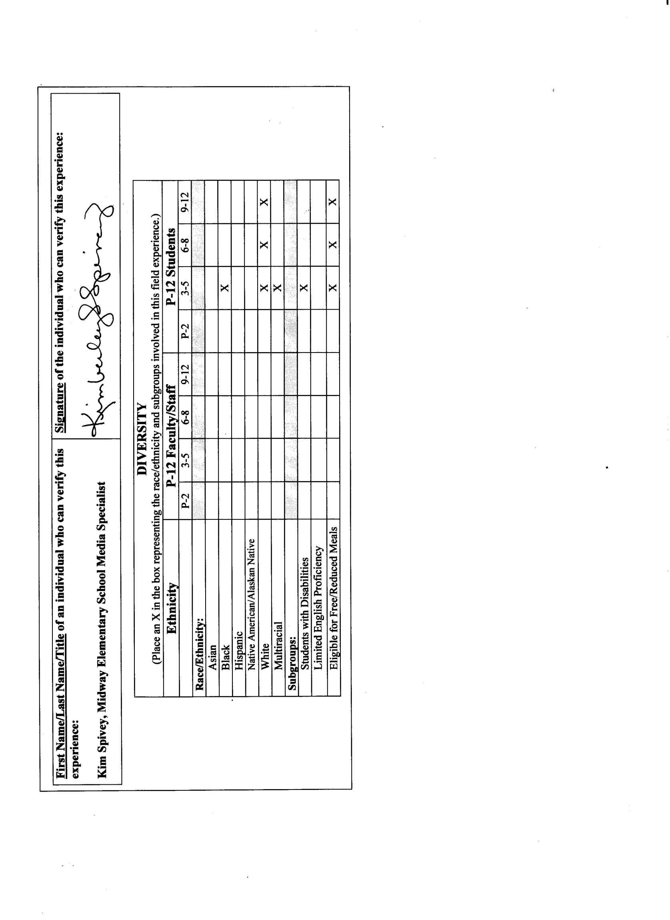

Reflection
(Minimum of 3-4 sentences per question)
1. Briefly describe the field experience. What did you learn about technology coaching and technology leadership from completing this field experience?

Because I was co-chair in creating the technology camp, I learned a lot about coaching and leading in the field of technology. Learning current technology uses and using up-to-date technology devices are both important when planning for educating others on technology. Having varied courses and encouraging student choice were also important in planning the camp. I also learned the importance of involving staff members who are both excited about and educated in the field of technology. Providing hands-on experiences, such as going on a field trip to a local t-shirt company for kids to see their camp shirts being printed, were beneficial and made the camp memorable for those who attended.

2. How did this learning relate to the knowledge (what must you know), skills (what must you be able to do) and dispositions (attitudes, beliefs, enthusiasm) required of a technology facilitator or technology leader? (Refer to the standards you selected above. Use the language of the PSC standards in your answer and reflect on all 3—knowledge, skills, and dispositions.)
Knowledge – Not only did I have to be aware of the technology being used at tech camp, I also had to make sure the teachers working the camp were aware as well. To thoroughly plan for the camp, I had several meetings with the teachers prior to camp, during the week of camp, and after camp to see how everything went. Knowing what one is teaching is essential in the learning process. As a teacher leader, I had to make sure teachers shared the same vision, planned strategically, and followed the policies and procedures that were set forth prior to camp.

Skills – In order for the technology camp to be effective, I had to be sure students were being taught by teachers who were skilled in the area of technology. I made sure teachers knew the standards they were teaching, used research-based learner-center strategies, promoted higher-order thinking skills, differentiated for learners when needed, modeled a clear instructional design, and facilitated a way to assess their students to check for learning and understanding. Students were given an authentic learning experience.

Dispositions – As a leader in technology, I had to have a visionary leadership and guide others in the direction that was best for our students. I had to model the characteristics of a digital citizen and show others how to model their responsibility in showing others to be digital citizens as well. I provided professional learning prior to camp for teachers to be clear in their expectations as a teacher for camp. At the end of camp, I gave parents, students, and teachers the opportunity to evaluate the program to provide efficient feedback (in order to improve for future participants).

3. Describe how this field experience impacted school improvement, faculty development or student learning at your school. How can the impact be assessed?

This field experience not only impacted school improvement by providing new and innovative ways for students to use technology, it also provided all of the others schools and teachers at each school in the county with the same opportunities. Because the technology camp was open to all schools and teachers at every school, unity took place among the students and teachers; the camp was housed at the school where I currently teach. The impact can be assessed through the surveys given to students, teachers, and parents of those who participated in the technology camp. I was proud to be a part of such a great experience!

