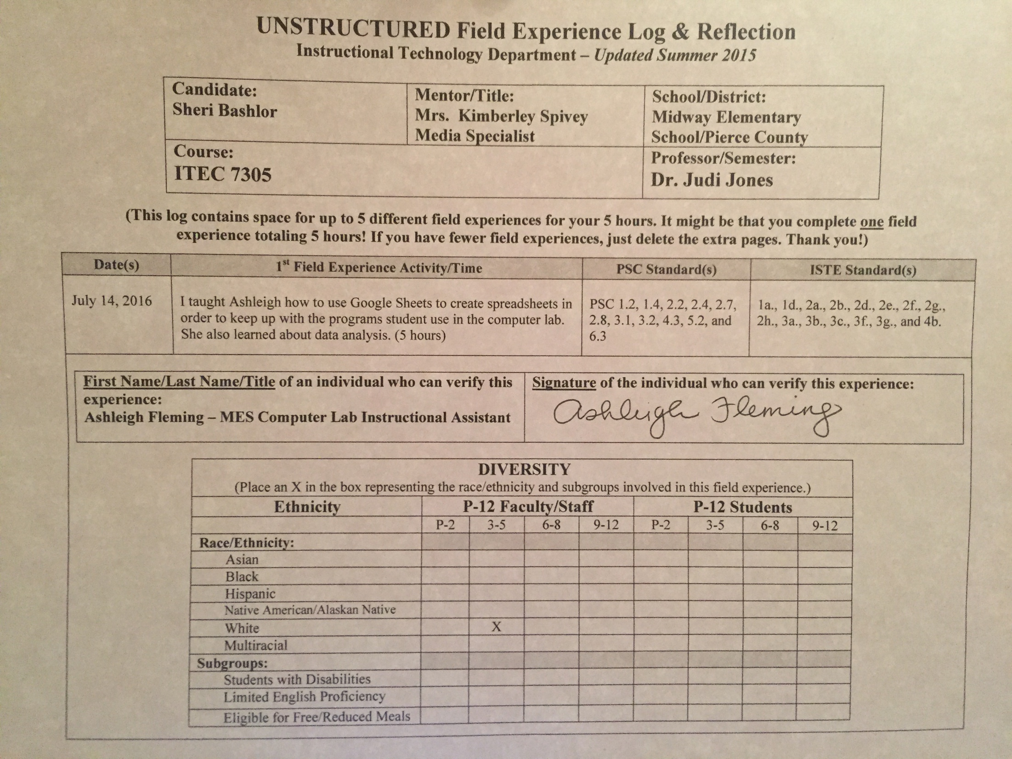

(This log contains space for up to 5 different field experiences for your 5 hours. It might be that you complete one field
experience totaling 5 hours! If you have fewer field experiences, just delete the extra pages. Thank you!)

Date(s) | 1st Field Experience Activity/Time | PSC Standard(s) | ISTE Standard(s)
July 14, 2016 | I taught Ashleigh how to use Google Sheets to create spreadsheets in order to keep up with the programs student use in the computer lab. She also learned about data analysis. (5 hours) | PSC 1.2, 1.4, 2.2, 2.4, 2.7, 2.8, 3.1, 3.2, 4.3, 5.2, and 6.3 | 1a., 1d., 2a., 2b., 2d., 2e., 2f., 2g., 2h., 3a., 3b., 3c., 3f., 3g., and 4b.
1. Briefly describe the field experience. What did you learn about technology coaching and technology leadership from completing this field experience?
Because Ashleigh works in the computer lab at our school, she is constantly having to take in data from different programs that the students use. She reports the information to the teachers; however, she does this just through a print-out from the programs themselves. In order to provide the teachers with more information and advance Ashleigh in data collection and analysis, she needed to learn more about data and how to display it. I taught her how to collect data, put it in a spreadsheet, and create graphs to show student progress over a period of time. With this instruction, she will be able to identify a lot more information about the learners in her computer lab and so will their teachers.

2. How did this learning relate to the knowledge (what must you know), skills (what must you be able to do) and dispositions (attitudes, beliefs, enthusiasm) required of a technology facilitator or technology leader? (Refer to the standards you selected above. Use the language of the PSC standards in your answer and reflect on all 3—knowledge, skills, and dispositions.)
Knowledge – I needed to know about Google Sheets and how to collect data, create a spreadsheet, create graphs, and share the data with others. I needed to be able to model this instruction and communicate it effectively, so Ashleigh would be able to use Google Sheets and directly share the information with the other teachers involved in student learning.
Skills – I needed to be able to model the effective use of Google Sheets and spreadsheets in general as well as how to analyze the data in different ways, such as for subgroups or strand specific. In addition, I needed to be able to communicate these skills with Ashleigh so she could understand them well, assist her when she needed help in creating them specific to the computer lab, and facilitate her learning while she was demonstrating what she learned.

Dispositions – In order to teach Ashleigh through this one-on-one professional development, I possess excellent communication skills as data analysis and collection can be confusing. I needed to be sure to provide her with resources that would be specific to her need as well as collaborate with her in creating sheets that would benefit the students in her computer lab classroom. I needed to be patient in assisting her learning and watch closely to make sure she understood what I had taught her. I also needed to provide encouragement to her during the process and stay positive.

3. Describe how this field experience impacted school improvement, faculty development or student learning at your school. How can the impact be assessed?

Because Ashleigh is the computer lab instructional assistant, she uses various programs to teach students. She wanted to learn a new way to collect information so she could share progress and student successes on the walls in her classroom. We decided it would be best for her to first learn how to create spreadsheets and add the information to the spreadsheets, in order to determine the students who are making adequate progress and for those who are not. I think this will vastly affect school improvement by helping Ashleigh collect information and share it with others as she teaches her computer lab.

