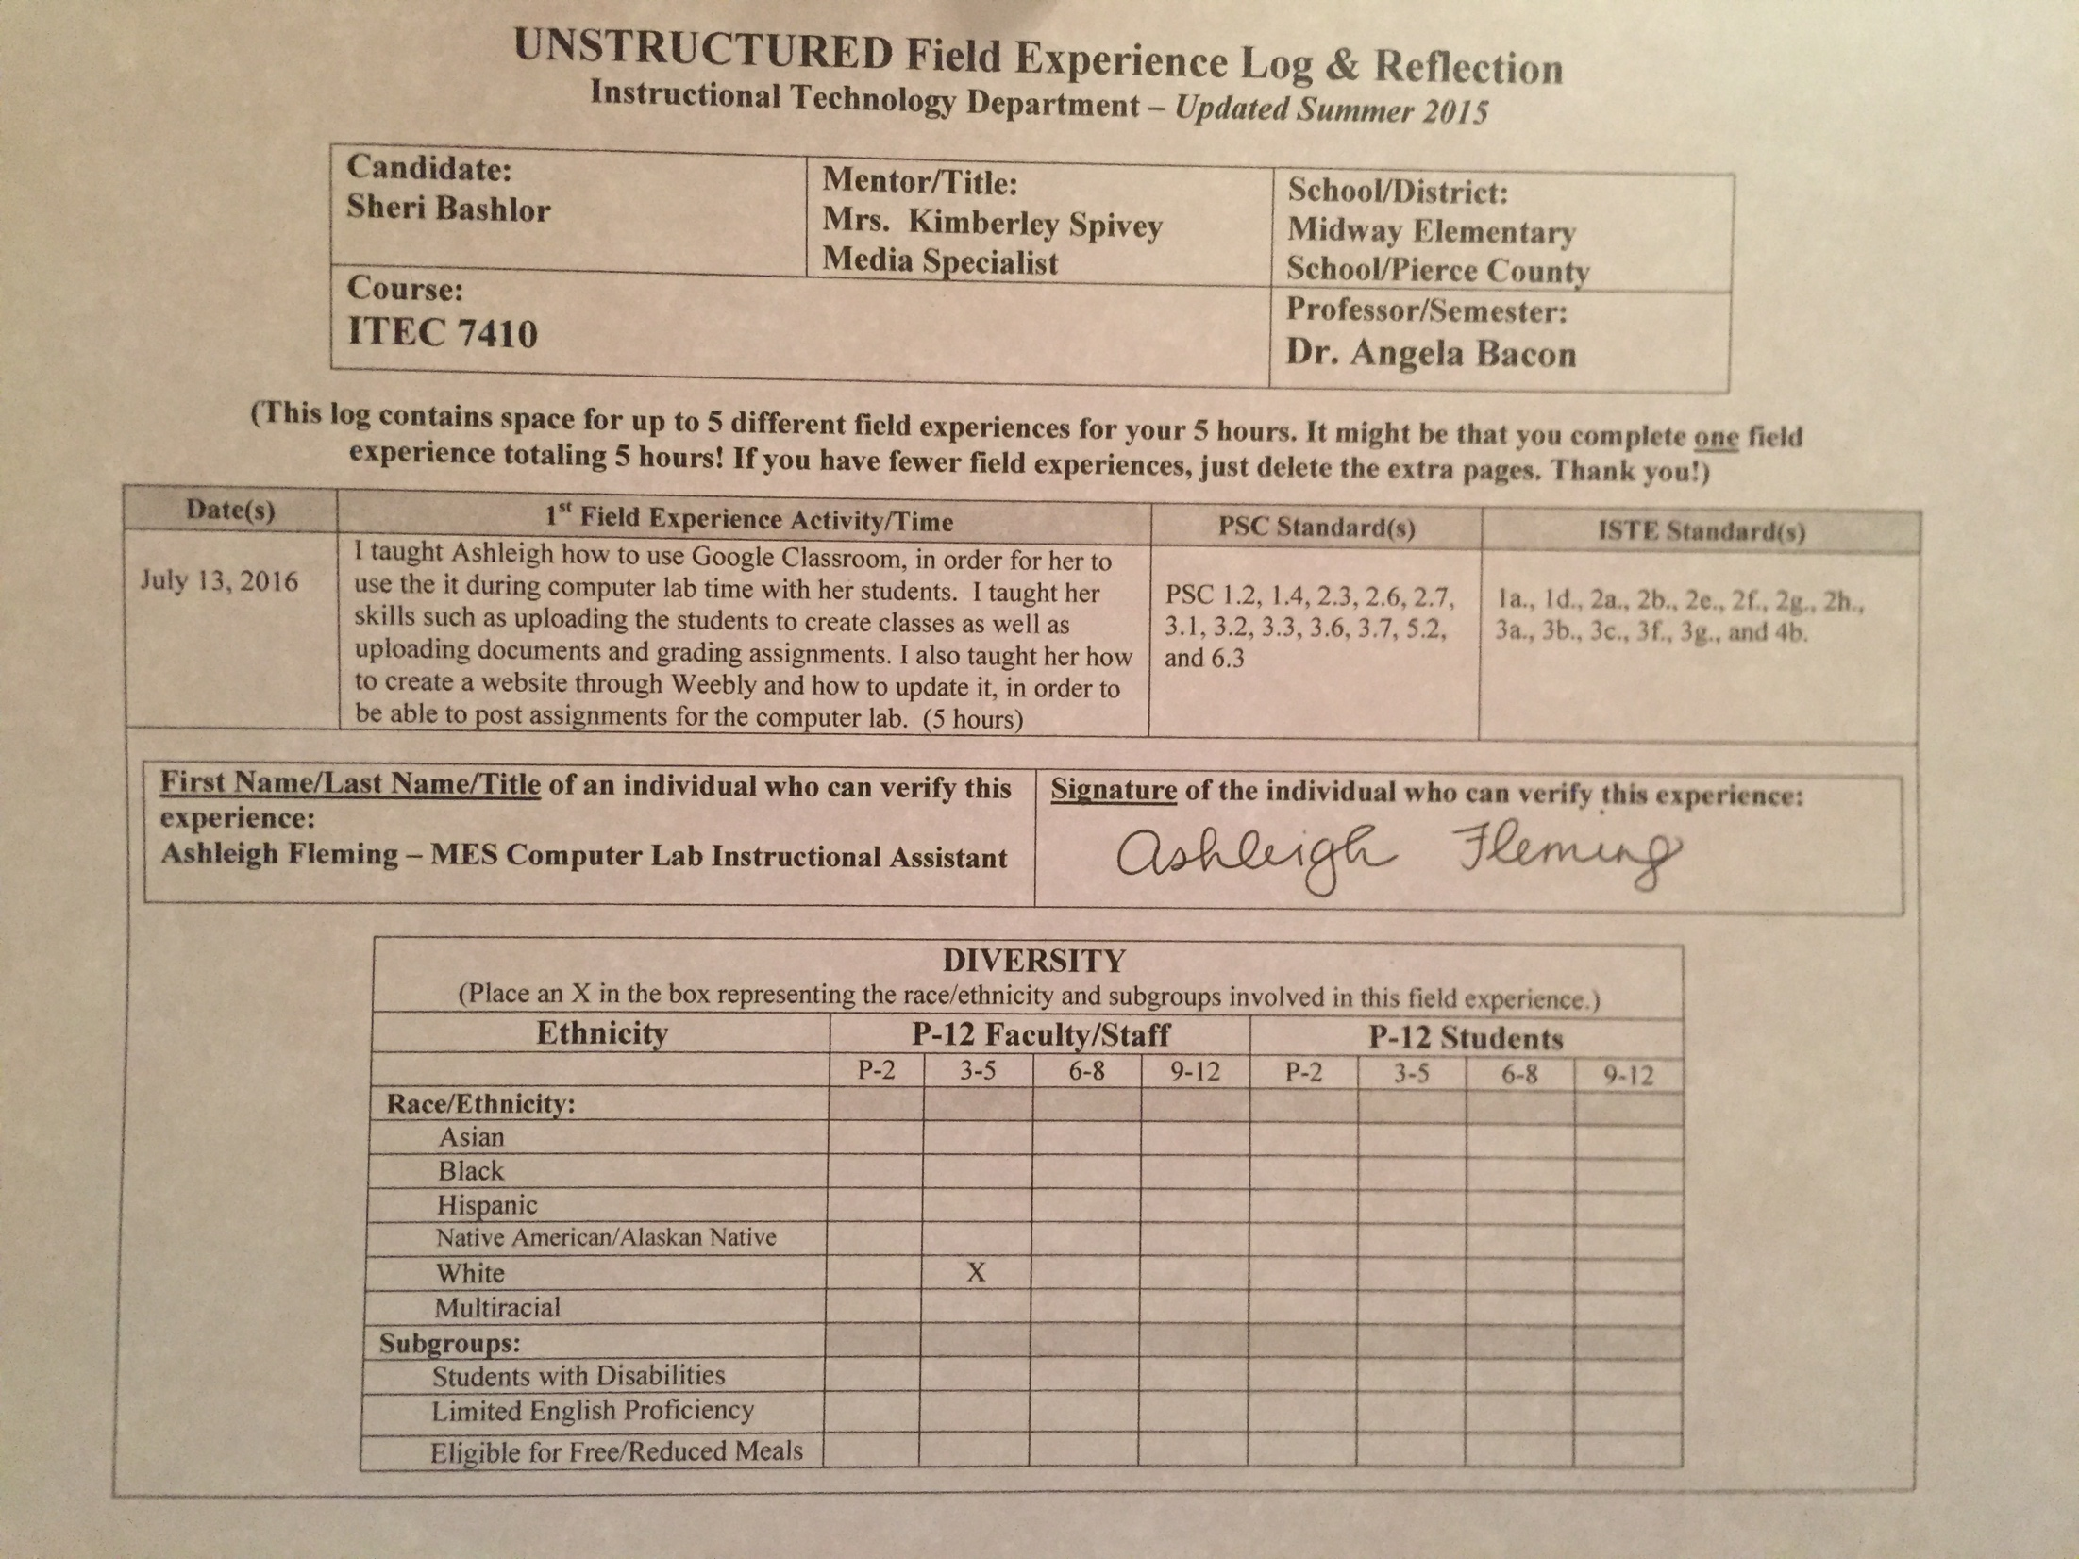
Reflection
(Minimum of 3-4 sentences per question)
1. Briefly describe the field experience. What did you learn about technology coaching and technology leadership from completing this field experience?
I learned the importance of first getting to know the skills of the person you’re helping as well as their position, in order to understand what exactly needs to be taught and where to begin. After I got a good idea of where Ashleigh was in her knowledge of technology, I was able to begin teaching her about Google Classroom, which is something she’s never used before. I taught Ashleigh how to import students to create a class, how to create a class, and the different ways a teacher can use Google Classroom. She learned how to upload documents for assignments and how to report grades to students. She had prior knowledge of Google Drive and had used Google Docs before, so she had some knowledge prior to beginning. In addition, I taught Ashleigh how to create a basic shell for a website through Weebly. During our Google instruction, she expressed her need and want to learn how to create a website as well; therefore, I taught her how to create one through Weebly. She seemed to learn a lot and enjoyed both experiences. I think she will use them in her profession later and now as the Instructional Assistant for the computer lab.

2. How did this learning relate to the knowledge (what must you know), skills (what must you be able to do) and dispositions (attitudes, beliefs, enthusiasm) required of a technology facilitator or technology leader? (Refer to the standards you selected above. Use the language of the PSC standards in your answer and reflect on all 3—knowledge, skills, and dispositions.)
Knowledge – I needed to know how to use Google Classroom and Weebly to the degree of teaching it to someone else. I needed to be able to break down information and teach her the beginning skills of using both, then build from those skills. I also needed to learn more about her prior knowledge of these two different platforms. I needed knowledge of the platforms as well, in order to explain how to use them for instructional design, classroom management, and collaborative learning. She can use these platforms to create an authentic learning experience for the students in her classroom.
Skills – I needed to be able to teach Ashleigh how to create an instructional design for her students but also allow her to include her own creativity and information as needed and desired. In addition, I needed to implement technology-based professional learning that would allow her to share with her students. I also needed to model my ideas and knowledge effectively.

Dispositions – In order to teach Ashleigh through this one-on-one professional development, I needed to be focused on her as my audience and see exactly how she could benefit from using the newfound information I was teaching her. The ability to collaborate, communicate effectively, and be positive and encouraging throughout the process was essential during the tasks we completed together.

3. Describe how this field experience impacted school improvement, faculty development or student learning at your school. How can the impact be assessed?

Because Ashleigh is the computer lab instructional assistant, she felt she could benefit from using Google Classroom during her instruction time as a teacher. This opportunity gave Ashleigh a head start on creating her classes and uploading her students for the upcoming school year, as well as planning and managing assignments through the Google platform when doing so. She will have a great foundation set when students start back to school, in order to provide an organized way of teaching and plan out her lesson plans. Although she isn’t new to this position, she is new to learning about Google Classroom.

