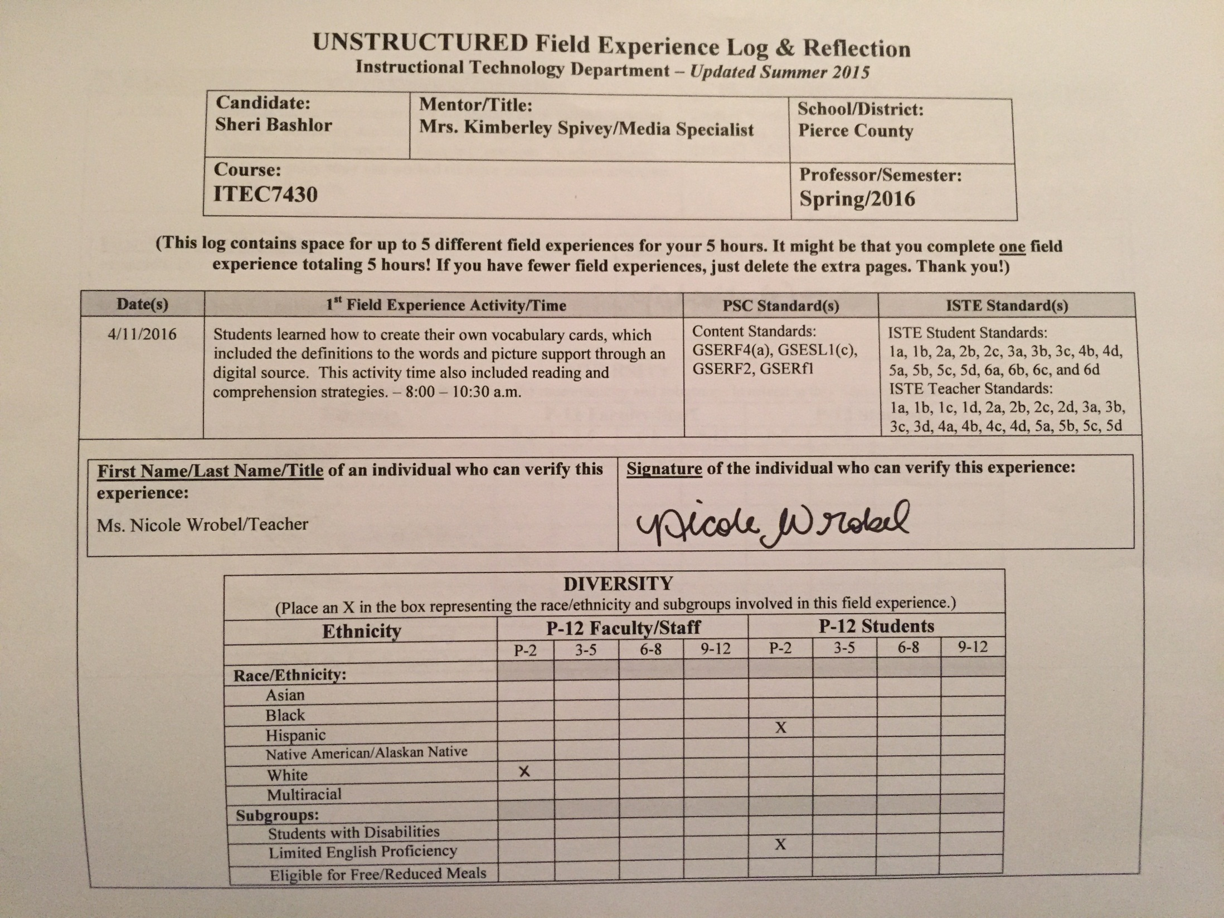

UNSTRUCTURED Field Experience Log & Reflection
Instructional Technology Department – Updated Summer 2015

Candidate:  Sheri Bashlor | Mentor/Title:  Mrs. Kimberley Spivey/Media Specialist  Ms. Nicole Wrobel/Teacher | School/District:  Pierce County
Course:  ITEC7430 |  | Professor/Semester:  Spring/2016

(This log contains space for up to 5 different field experiences for your 5 hours. It might be that you complete one field
experience totaling 5 hours! If you have fewer field experiences, just delete the extra pages. Thank you!)

Date(s) | 1st Field Experience Activity/Time | PSC Standard(s) | ISTE Standard(s)
4/11/2016 | Students learned how to create their own vocabulary cards, which included the definitions to the words and picture support through an digital source. This activity time also included reading and comprehension strategies. – 8:00 – 10:30 a.m. | Content Standards: GSERF4(a), GSESL1(c),  GSERF2, GSERf1 | ISTE Student Standards:  1a, 1b, 2a, 2b, 2c, 3a, 3b, 3c, 4b, 4d, 5a, 5b, 5c, 5d, 6a, 6b, 6c, and 6d  ISTE Teacher Standards:  1a, 1b, 1c, 1d, 2a, 2b, 2c, 2d, 3a, 3b, 3c, 3d, 4a, 4b, 4c, 4d, 5a, 5b, 5c, 5d
First Name/Last Name/Title of an individual who can verify this experience:  Ms. Nicole Wrobel/Teacher | Signature of the individual who can verify this experience:  See above for signature.

DIVERSITY
(Place an X in the box representing the race/ethnicity and subgroups involved in this field experience.)
Ethnicity | P-12 Faculty/Staff |  |  |  | P-12 Students
 | P-2 | 3-5 | 6-8 | 9-12 | P-2 | 3-5 | 6-8 | 9-12
Race/Ethnicity:
Asian
Black
Hispanic |  |  |  |  | X
Native American/Alaskan Native
White | X
Multiracial
Subgroups:
Students with Disabilities
Limited English Proficiency |  |  |  |  | X
Eligible for Free/Reduced Meals

Reflection
(Minimum of 3-4 sentences per question)
1. Briefly describe the field experience. What did you learn about technology coaching and technology leadership from completing this field experience?
First grade ESOL students learned how to create a PowerPoint to display their knowledge about their weekly vocabulary words. For each vocabulary word, I accessed their prior knowledge of the word by asking questions that would help me know exactly how much they knew about the word or definition. I then introduced the vocabulary word. We spelled it with magnetic letters on their cookie sheet. Once students were introduced to each word, I taught them how to create a PowerPoint slide to include the vocabulary word, definition, and picture (learned how to copy and paste from the Internet). In addition, they learned how to use dictionary.com on the iPads to access the definition of the words that they do not know. Once we had created a slide for each vocabulary word, students then read an excerpt from the book, Nate the Greate Saves the King of Swenden (pages 25-30). I read the story first. Students then used choral reading to read the pages. We used different comprehension strategies throughout the reading. We reviewed the first part of the story prior to reading, activated background knowledge by asking questions that would associate the students with the characters in the book, and asked questions throughout reading. I planned with the first grade teacher prior to this lesson, and we met after the lesson was complete. She was impressed that the students were able to learn how to create a PowerPoint so easily and said it was definitely a strategy she will use in the future for all of her students who need the extra support. She felt like it would also be a great activity to use for the weekly story, and wished she would have started from the beginning of the book. We discussed that computer-lab time would be a great time for all students to learn how to use this strategy, so students would know exactly what to do in the classroom. This is a great way to differentiate learning in the classroom as well.

2. How did this learning relate to the knowledge (what must you know), skills (what must you be able to do) and dispositions (attitudes, beliefs, enthusiasm) required of a technology facilitator or technology leader? (Refer to the standards you selected above. Use the language of the PSC standards in your answer and reflect on all 3—knowledge, skills, and dispositions.)
Knowledge – I needed to understand the learning level of first grade students, as I need to understand that for all levels within the school I am working. In addition, I needed to understand the capabilities of the students in the room as well as their technical skills (which most had from working in computer lab). I needed background information of the ESOL students and to get to know them through conversation (with helped with their conversational skills as well). It’s important for technology leaders and facilitators to understand the age development of the students in the classroom where she’s helping the student, so she can plan appropriate activities for them to utilize and use. It’s always important for teachers to be knowledge in the subject and content matter as well as the technology in order to facilitate the experiences students need in order to grow as a learner.

Skills – I needed to know how to create a PowerPoint myself and make it easy for first grade students to understand during implementation. It’s important that technology leaders understand the technical skills both teachers and students know prior to introducing something new to them. Just like students, teachers need to have their prior knowledge accessed to help make the transition of using technology in the classroom seamless. Not only did I need to know how to advocate and model how to be a good digital citizen, I had to remind the teacher to do this as well (reminding students not to Google things at home due to filters and tips such as that).
Dispositions – With technology integration in classrooms that normally do not use or facilitate technology within their lessons, it’s essential to have an optimistic attitude when teaching others how to utilize the new tool about which you are teaching them. Many teachers seem to get frustrated when integrating technology in the classroom and finding technology that’s developmentally appropriate for their students to use. As a teacher leader, it was important for me to promote technology in a positive light and provide the support that the students and teacher needed for the lesson to be successful.
3. Describe how this field experience impacted school improvement, faculty development or student learning at your school. How can the impact be assessed?

Not only did I help a first grade teacher learn a new strategy to help with vocabulary instruction to her ESOL students, I also reached out to the computer lab teacher and shared the information with her as well. The first grade teacher I worked with said she was going to share the strategy with her teammates, and she hoped for them to get excited about the products her students created in the classroom. I think the impact could definitely be assessed by keeping up with the weekly vocabulary test scores of the students prior to using this strategy (in grade book) and comparing the scores to the ones where students are using this strategy. The impact of teachers can be assessed by their comments, questions, and concerns. I think I’m going to create a Google Form for teachers to express whether or not they think this strategy is one they will continuing using. I can also share the data results with the computer lab teacher once skills are taught. Although the computer lab teacher does use her time to teach these types of skills in the lab, I did explain to the first grade teacher I felt she still needed to review PowerPoint skills in the classroom so their knowledge will be reignited and transitioned to their regular classroom setting. The ESOL teacher is planning on using this strategy during her pull-out and push-in times as well. She loved it!

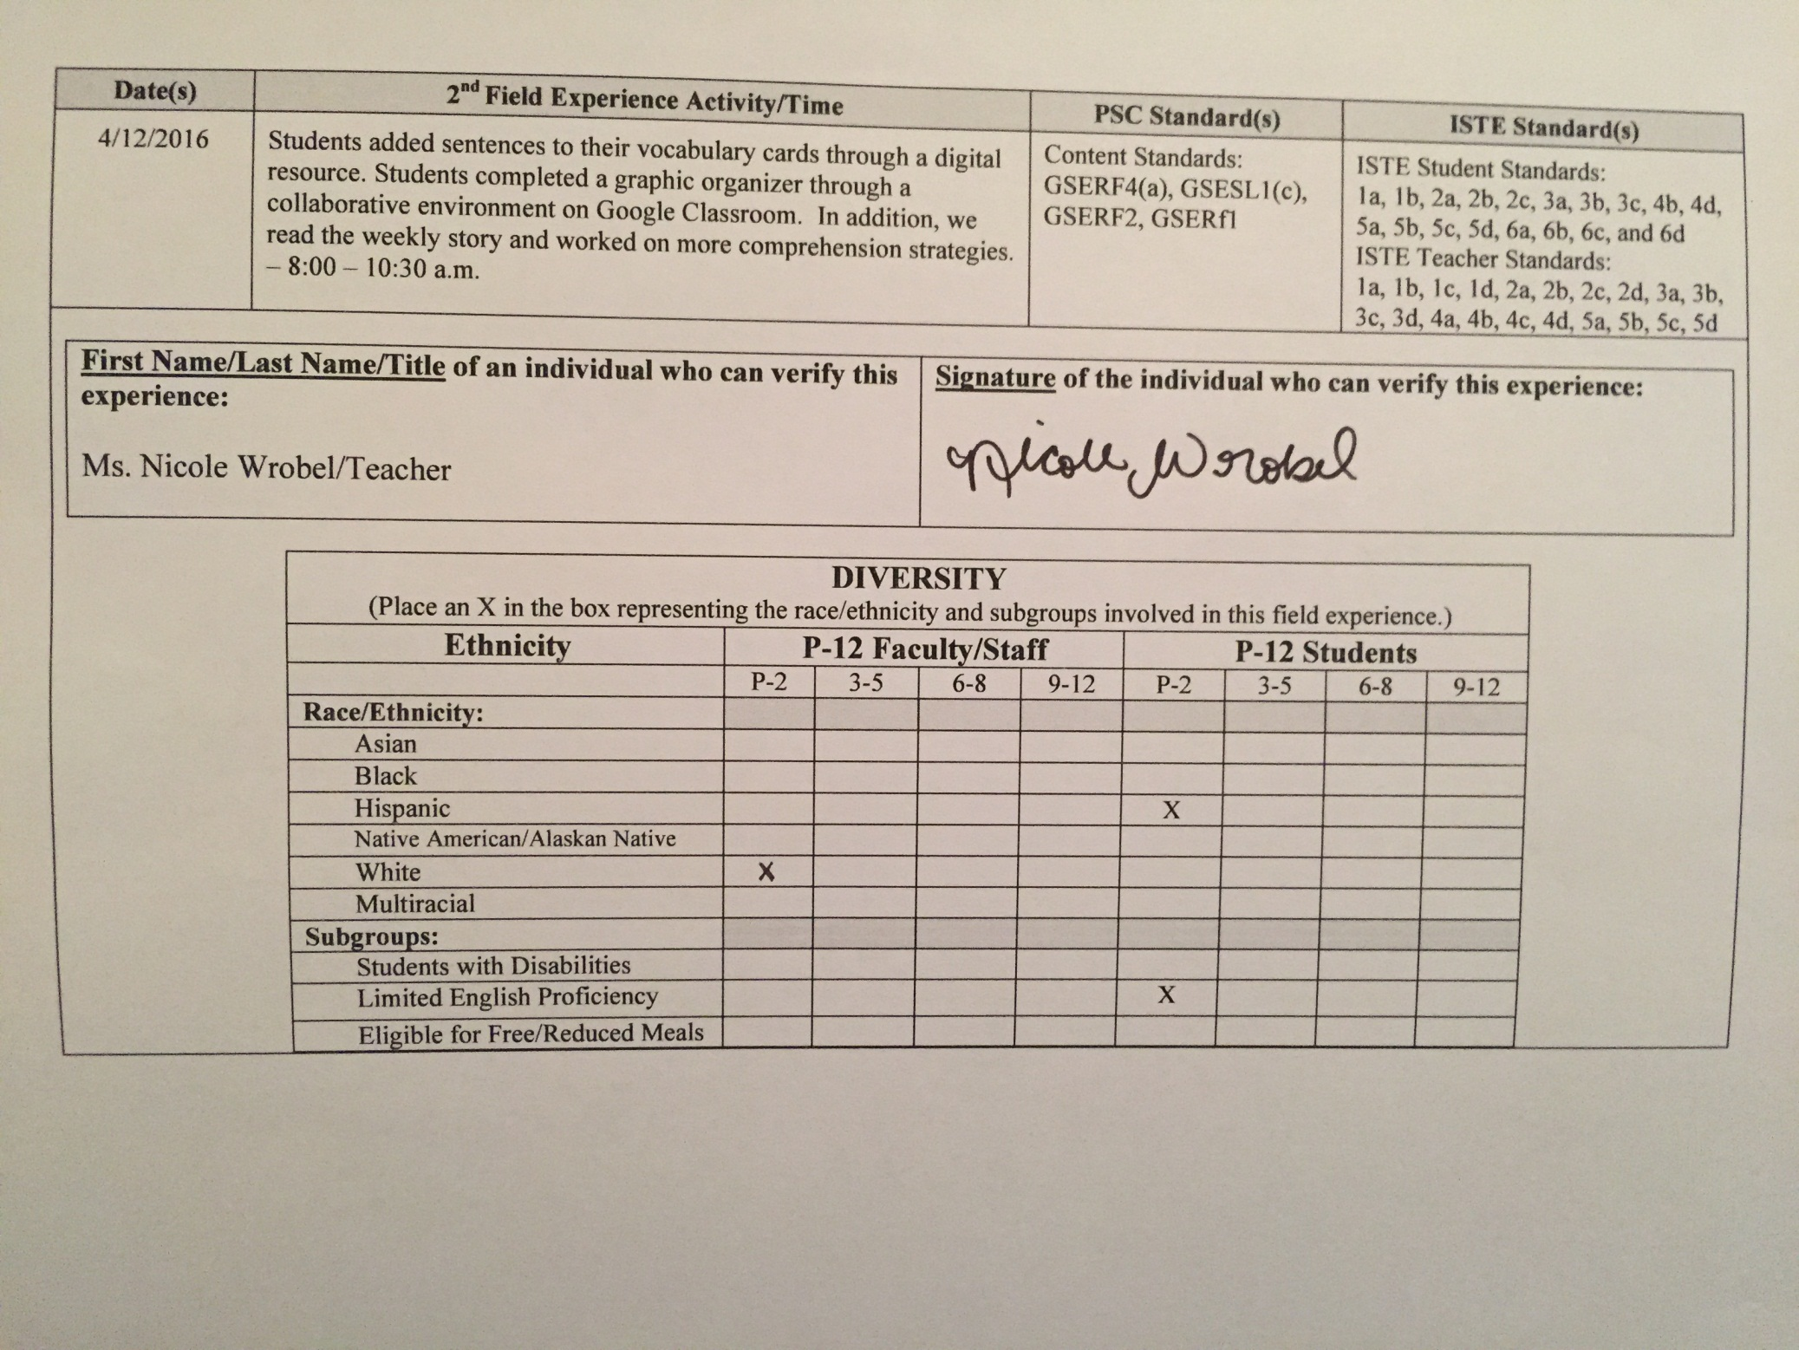

Date(s) | 2nd Field Experience Activity/Time | PSC Standard(s) | ISTE Standard(s)
4/12/2016 | Students added sentences to their vocabulary cards through a digital resource. Students completed a graphic organizer through a collaborative environment on Google Classroom. In addition, we read the weekly story and worked on more comprehension strategies. – 8:00 – 10:30 a.m. | Content Standards: GSERF4(a), GSESL1(c),  GSERF2, GSERf1 | ISTE Student Standards:  1a, 1b, 2a, 2b, 2c, 3a, 3b, 3c, 4b, 4d, 5a, 5b, 5c, 5d, 6a, 6b, 6c, and 6d  ISTE Teacher Standards:  1a, 1b, 1c, 1d, 2a, 2b, 2c, 2d, 3a, 3b, 3c, 3d, 4a, 4b, 4c, 4d, 5a, 5b, 5c, 5d
First Name/Last Name/Title of an individual who can verify this experience:  Ms. Nicole Wrobel/Teacher | Signature of the individual who can verify this experience:  See above for signature.

DIVERSITY
(Place an X in the box representing the race/ethnicity and subgroups involved in this field experience.)
Ethnicity | P-12 Faculty/Staff |  |  |  | P-12 Students
 | P-2 | 3-5 | 6-8 | 9-12 | P-2 | 3-5 | 6-8 | 9-12
Race/Ethnicity:
Asian
Black
Hispanic |  |  |  |  | X
Native American/Alaskan Native
White | X
Multiracial
Subgroups:
Students with Disabilities
Limited English Proficiency |  |  |  |  | X
Eligible for Free/Reduced Meals

Reflection
(Minimum of 3-4 sentences per question)
1. Briefly describe the field experience. What did you learn about technology coaching and technology leadership from completing this field experience?

Students added sentences they created to their PowerPoint vocabulary presentations today. In addition to that activity, we reviewed what we have read so far in Nate the Great Saves the King of Sweden. We then worked on comprehension strategies before, during, and after reading pages 31-36 in the book. I went a little out of the teacher’s comfort zone today by having the students sign into their email accounts; this task did take two of us (and some of my gifted students who do this regularly) to help others sign in. I was glad that I had previously taught my students to sign in and how to use Google Classroom, Drive, and Gmail. Even though we only used the Drive part, they were a HUGE help today. For all grades, I think training a group of students prior to teaching the entire class how to use a device or resource is a great idea to provide support to the teachers for helping other students during the entire process. Once students signed into their Gmail, they learned how to pull up Drive and a shared Google Draw document (students were partnered with students who knew how to use it and the teacher was partnered with me during this time). The document I shared with them was a graphic organizer I created through Google Draw, where students were able to complete the organizer as a class. We discussed the story elements. Students would type in their answers (each group was assigned a different part to type). Of course, this took some time since first grade students aren’t the fastest at typing; however, the responses weren’t lengthy enough for the time to cause a big difference in the lesson. The students LOVED doing this and seeing other answers pop up as students were typing them in. Of course, we had to firmly say they couldn’t type without it being something we discussed and went over first. As a teacher leader, I felt I accomplished a lot today. The teacher was amazed at what we did with Google and although she was uncomfortable at first, she caught on quickly and was surprised at the progress the students made. The teacher told me she wanted to start planning that way, collaboratively with her teammates and was going to show the other teachers on her team how to do this. I learned that sharing technology in the classroom can be very rewarding; I felt as though not only did I help the teacher and possibly her teammates, but the students would benefit from the new learning that the teacher delved into today.

2. How did this learning relate to the knowledge (what must you know), skills (what must you be able to do) and dispositions (attitudes, beliefs, enthusiasm) required of a technology facilitator or technology leader? (Refer to the standards you selected above. Use the language of the PSC standards in your answer and reflect on all 3—knowledge, skills, and dispositions.)
Knowledge – I needed to understand the learning level of each of the students today and how to pair them, which the teacher helped with that as well. In collaborative pairs, we made sure each pair had one student who had been pre-exposed to the process of using Google. This helped a lot. I also had to know the content levels and knowledge (as well as the teacher’s) in order to facilitate the learning experience to its fullest capacity.
Skills – For technology, I needed to fully understand how to create the graphic organizer and share it with others in order for them to edit as well. As a leader, I needed to expose the teacher to both the creation process (during planning) of the graphic organizer and completion of it as well; I needed to make sure she understood the skill so she could use it as a take-away for her team. I modeled using good practices and etiquette while doing so, and I warned the teacher that students may try to fill in the graphic organizer if they were not instructed to specifically not to unless it was their turn.
Dispositions - I believe positivity and pre-viewing the lesson together helped a lot. Because the students had a successful outcome the day before with the PowerPoint Presentations, the teacher was confident that the students could complete the task at hand today. She also saw their ease in adding to the presentations. Once those were complete, I told her I thought it would be a good idea to email the parents to share with them (especially the ESOL students, in order for them to practice at home). For those students who don’t have parents with an email, we printed the presentations out for the students to practice for the next several days prior to their tests. I told her I think it would be a great idea to keep a vocabulary book that is ongoing (like a dictionary for them) so students can review words when needed and during holidays and summers. She loved the idea, and said she’s definitely going to implement the books for them to use. Communication and collaboration are also great characteristics and dispositions in which both teachers and leaders should have and display.
3. Describe how this field experience impacted school improvement, faculty development or student learning at your school. How can the impact be assessed?

I think the field experience improved the knowledge of the teacher in the regular first grade classroom, knowledge of the ESOL teacher in the use of technology tools with first graders, and with the computer-lab teacher. These teachers are excited to share with their teammates and with other teachers in the school. Because of it, I am planning on doing a school-wide training on Google Classroom and Tools to use in the classroom. I think teachers will and students will benefit from teaching professional development in this area. The impact can be assessed by comparing scores to both weekly vocabulary and comprehension tests as well as the monitoring of teacher-use of the resources once learned and used within the classroom.

